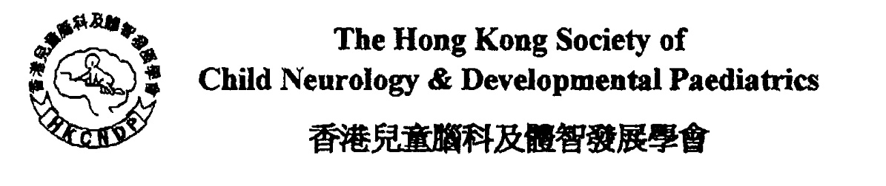

**Neurodevelopmental Conference**

**The Paediatric TMS Neuromodulation Program :**

**From diagnosis to intervention**

**Dr Tso W.Y. Winnie**

**Assistant Dean (Community Engagement)**

**Clinical Assistant Professor,**

**The Department of Paediatrics & Adolescent Medicine**

**Li Ka Shing Faculty of Medicine**

**The University of Hong Kong**

**Dr Lau S.N. Sarah**

**Associate consultant, Department of Neurosurgery, Queen Mary Hospital**

**Ms. Fan C.Y. Charlie**

**Occupational Therapist, MPhil (The Department of Paediatrics & Adolescent Medicine**

**Li Ka Shing Faculty of Medicine, The University of Hong Kong)**

**Chairman: Dr Stephanie Liu, HKCNDP**

**30th April, 2025. (Wednesday)**

**19:00 to 20:00 pm Lecture**

**20:00 to 20:15 pm Q&A**

**Format: Online by Zoom**

**Meeting ID 835 3237 6267**

**Password 419172**

**https://us06web.zoom.us/j/83532376267?pwd=wuFMaayqrXqVOiufs9Lbv1pyxDwf1J.1**

### **Hong Kong College of Paediatricians Accredited Activity: pending point**

### **The Collge of Surgeons of Hong Kong (Neurosurgery) : pending point**

### **Hong Kong College of Psychiatrists Accredited Activity: pending point**

**Hong Kong College of Family Physicians Accredited Activity: pending point**

**CME program for non-specialists of the Medical Council of Hong Kong: pending point**

**HKOTA CPD points: pending point**

**HKPA CPD: pending point**